EICC Email Signature Template

Your Name preferred/pronouns/here
Position or Title
Campus Name
Street Address, City
563-555-5555 | eicc.edu

Eastern Iowa Community Colleges is an Equal Opportunity Educator and Employer.

Follow the instructions to use the template:
Step 1: Hover over the signature and click to select all the elements in the signature.
Step 2: Select Copy (Ctrl + C).
Step 3: Open an Outlook and select ‘Options’ under ‘File’
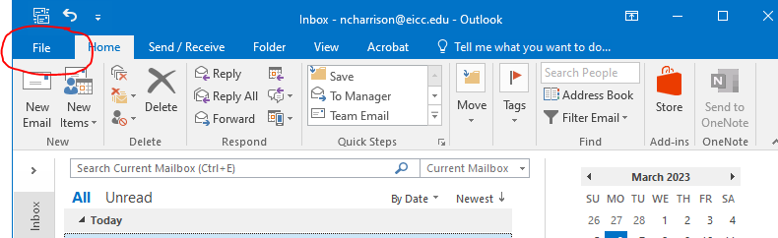
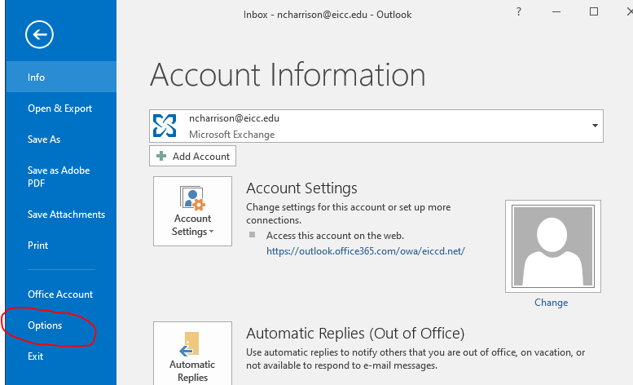

Step 4: In the ‘Mail’ tab, click on the ‘Signatures…’ button
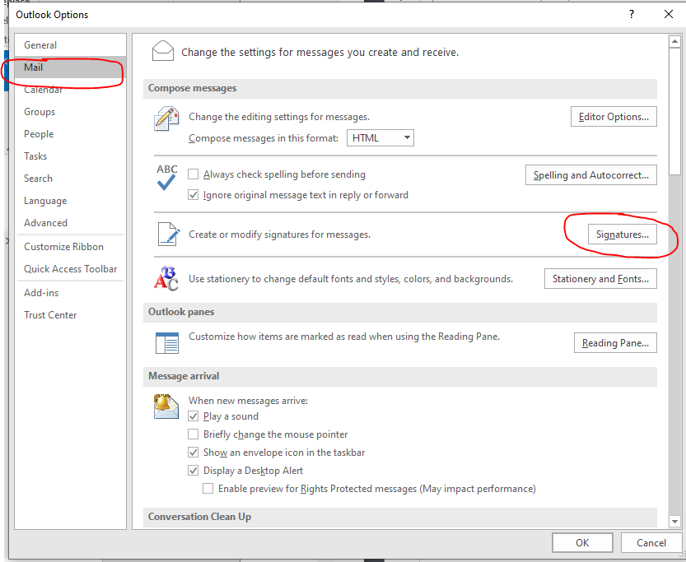

Step 5: Click on the ‘New’ button under ‘Select signature to edit’ and name the new signature. Click ‘Ok’.
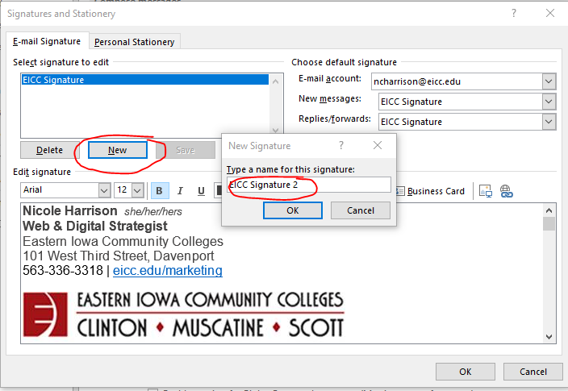

Step 6: In the ‘Edit signature’ box select Paste (Ctrl + V). With the template signature pasted, update the placeholder information to yours.
You will need to hyperlink ‘eicc.edu’ and ‘Eastern Iowa Community Colleges is an Equal Opportunity Educator and Employer.’* To do this highlight the link and click on the link icon and update the ‘Address:’ field to the correct URL and click ‘Ok’.
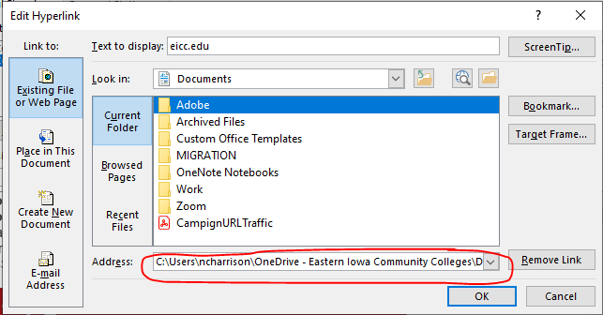
Eastern Iowa Community Colleges is an Equal Opportunity Educator and Employer. Should be linked to https://eicc.edu/eeo

